Program 1: Password Strength Checker:
Code:
# Password Strength Checker

password = input("Enter Password: ")

has_upper = False
has_lower = False
has_digit = False

# Check password length
if len(password) >= 8:
# Check each character
for char in password:
if char.isupper():
has_upper = True
elif char.islower():
has_lower = True
elif char.isdigit():
has_digit = True

# Check all conditions
if has_upper and has_lower and has_digit:
print("Password is Strong.")
else:
print("Password is Weak.")
else:
print("Password is Weak.")
Output:
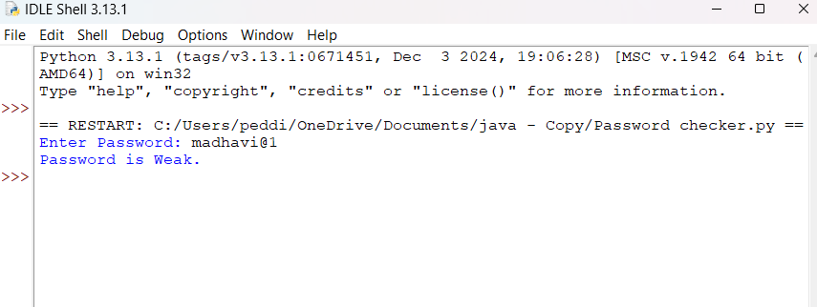

Program 2: Login Authentication
Code:
# Login Authentication

correct_username = "admin"
correct_password = "Admin123"

username = input("Enter Username: ")
password = input("Enter Password: ")

if username == correct_username and password == correct_password:
print("Login Successful.")
else:
print("Invalid Username or Password.")

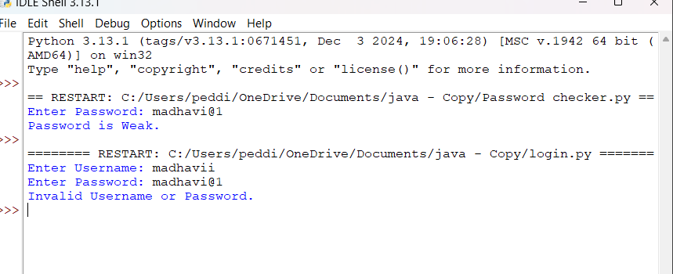
Program 3: File Access Permission Simulation
Code:
# File Access Permission Simulation

role = input("Enter Role: ").strip().lower()

print("Permissions:")

if role == "admin":
print("Read")
print("Write")
print("Delete")
elif role == "faculty":
print("Read")
print("Write")
elif role == "student":
print("Read Only")
else:
print("Invalid Role")
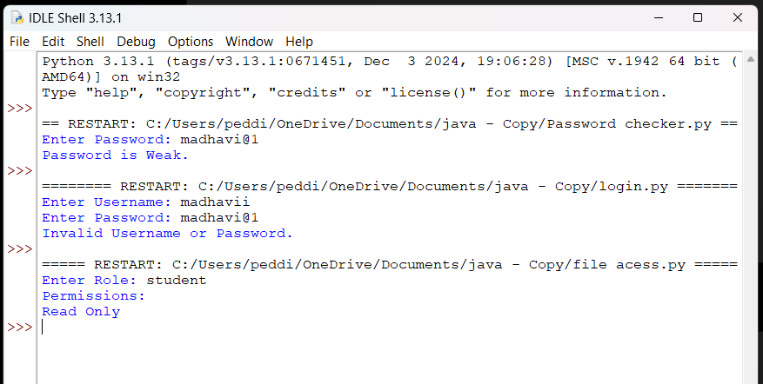

Program 4: Bell–LaPadula Access Checker
# Bell-LaPadula Security Model

levels = {
"Public": 1,
"Confidential": 2,
"Secret": 3,
"Top Secret": 4
}

user_level = input("User Level: ")
file_level = input("File Level: ")
operation = input("Operation (Read/Write): ")

if user_level not in levels or file_level not in levels:
print("Invalid Security Level")
else:
user = levels[user_level]
file = levels[file_level]

if operation.lower() == "read":
if user >= file:
print("Access Allowed")
else:
print("Access Denied")
print("Reason : No Read Up")

elif operation.lower() == "write":
if user <= file:
print("Access Allowed")
else:
print("Access Denied")
print("Reason : No Write Down")

else:
print("Invalid Operation")

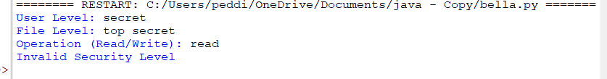

Program 5: Security Risk Level Calculator
# Security Risk Level Calculator

threat = int(input("Enter Threat Level (1-10): "))
vulnerability = int(input("Enter Vulnerability Level (1-10): "))

risk = threat * vulnerability

print("Risk Score:", risk)

if risk < 20:
print("Risk Level: Low Risk")
elif risk <= 50:
print("Risk Level: Medium Risk")
else:
print("Risk Level: High Risk")

